Spring Data JPA - Quick Example
Create a Eclipse Project using Spring Initializr

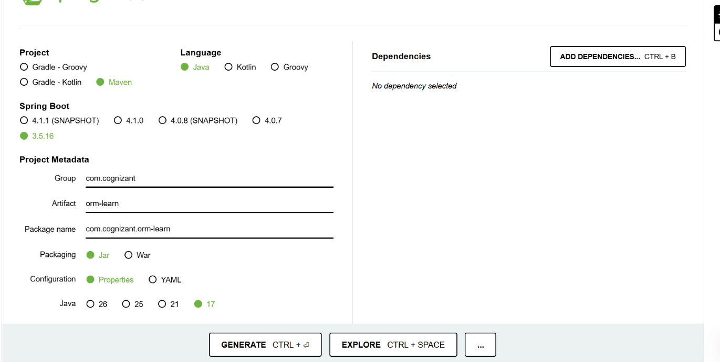
Database/schema creation
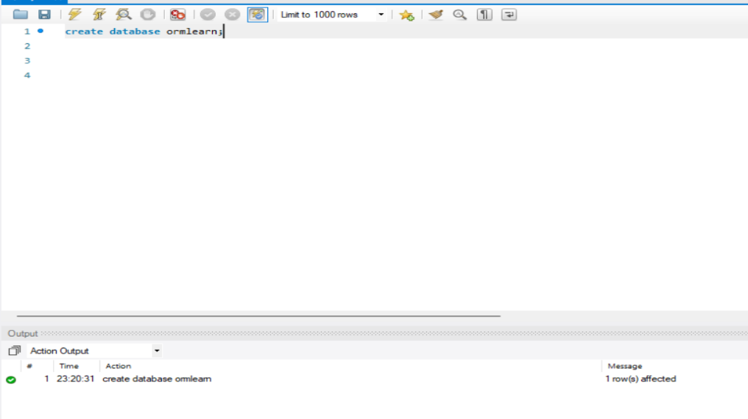
Application.properties
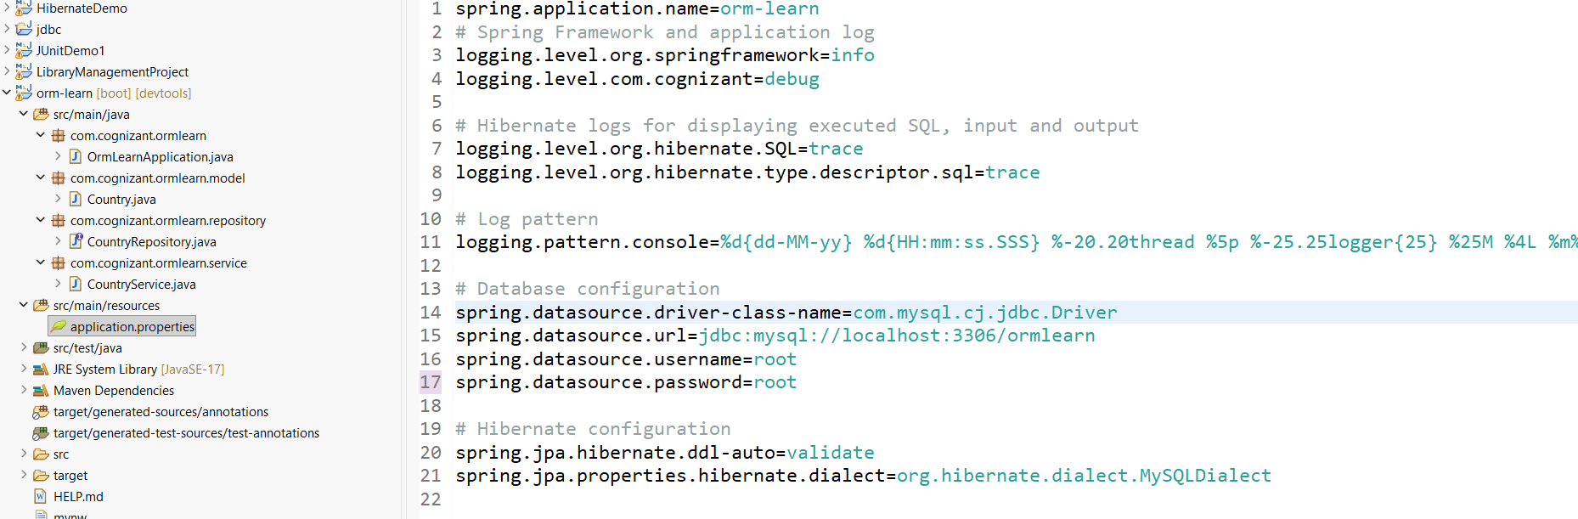
Build the project using command in the command line
mvn clean package -Dhttp.proxyHost=proxy.cognizant.com -Dhttp.proxyPort=6050 -Dhttps.proxyHost=proxy.cognizant.com -Dhttps.proxyPort=6050 -Dhttp.proxyUser=123456’
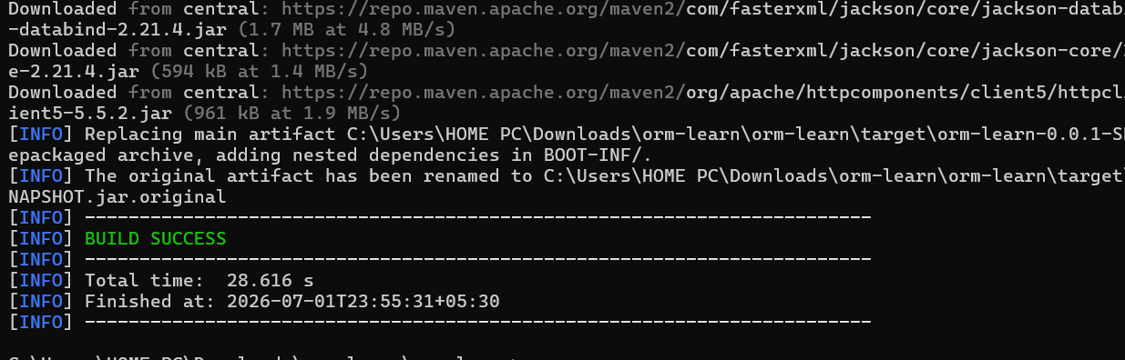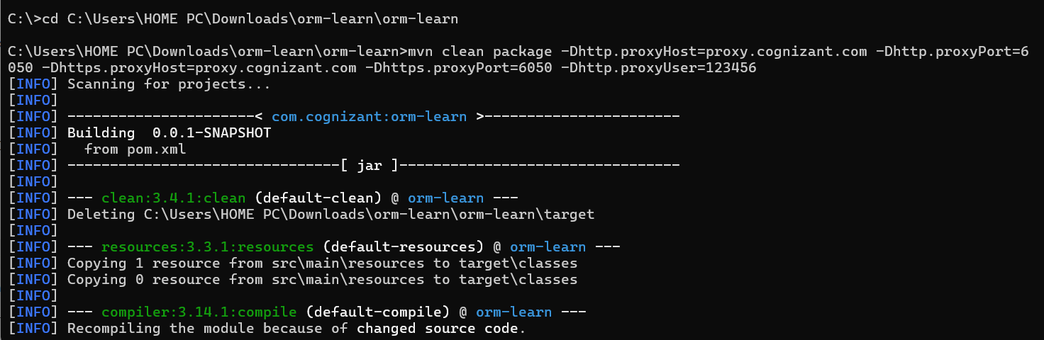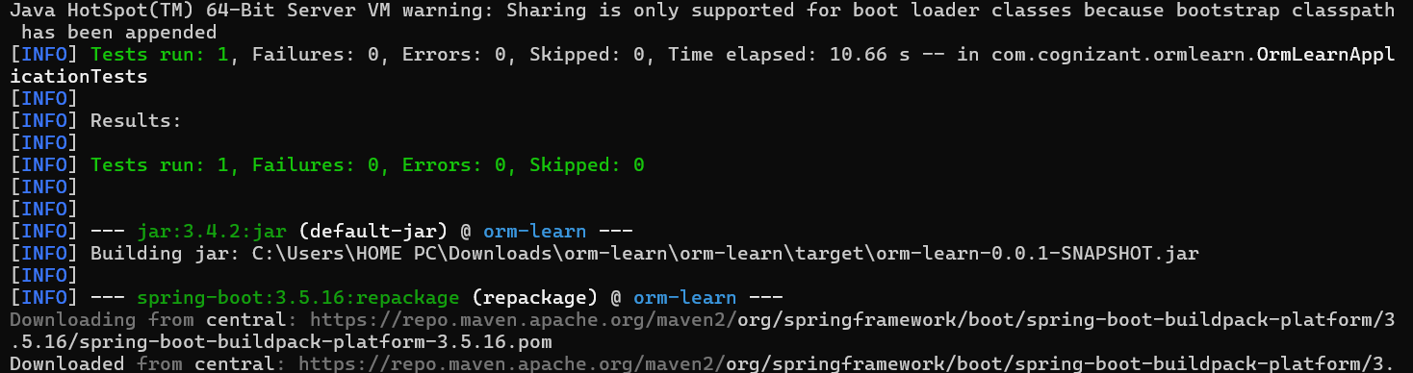
Folder structure
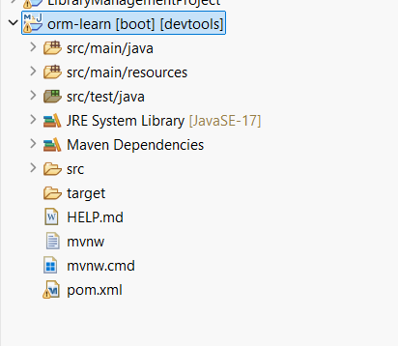
Table creation
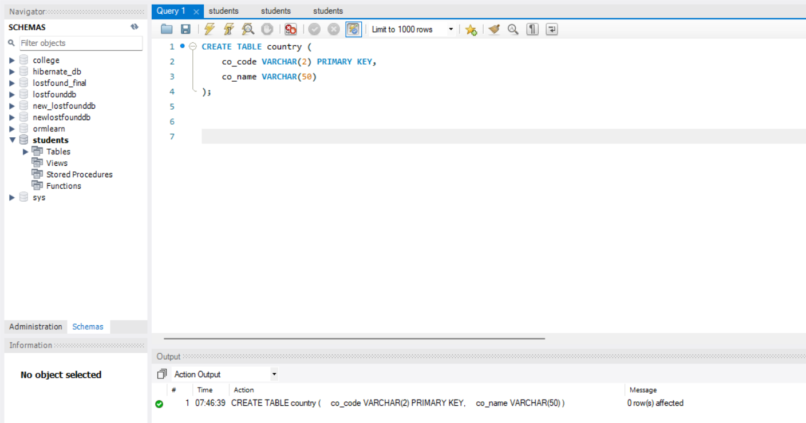
Insertion of Query
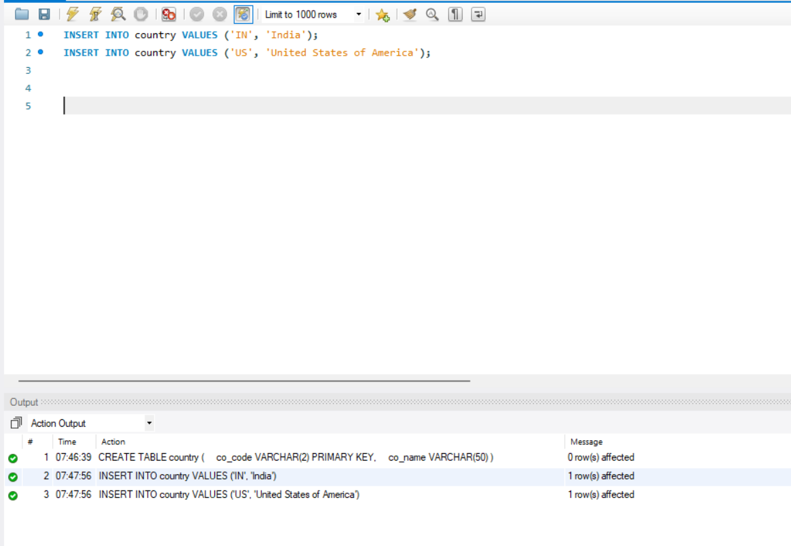
Display table:
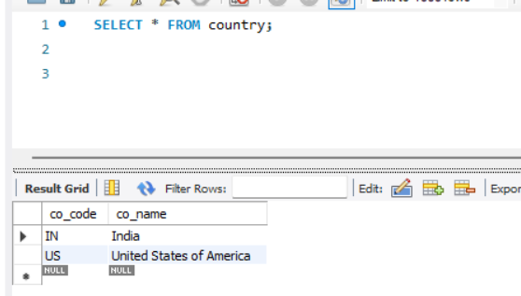
Country.java
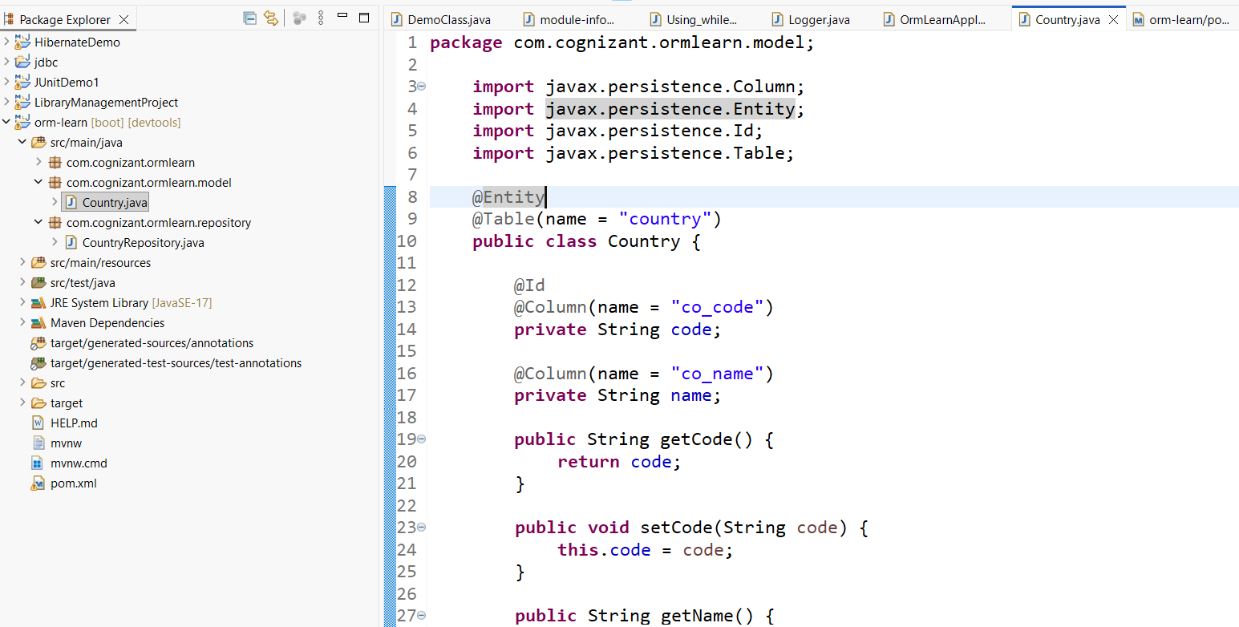
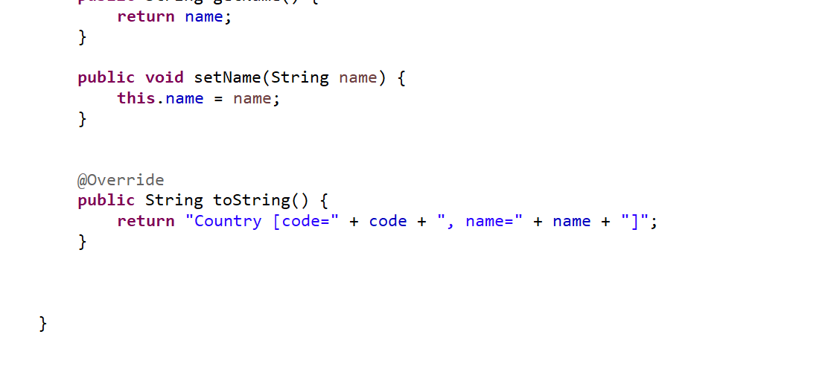
CountryRepository interface
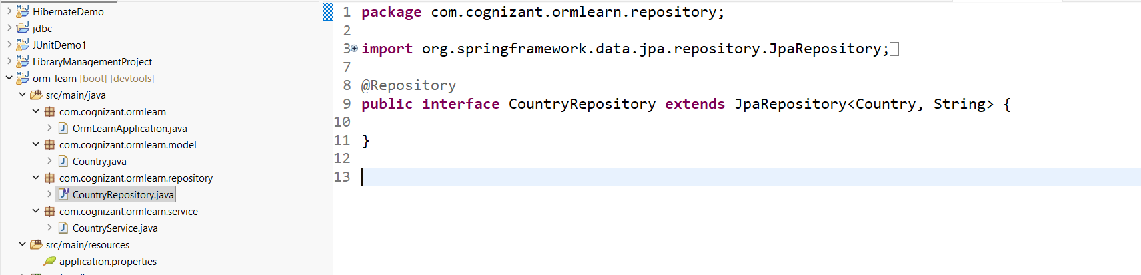
CountryService
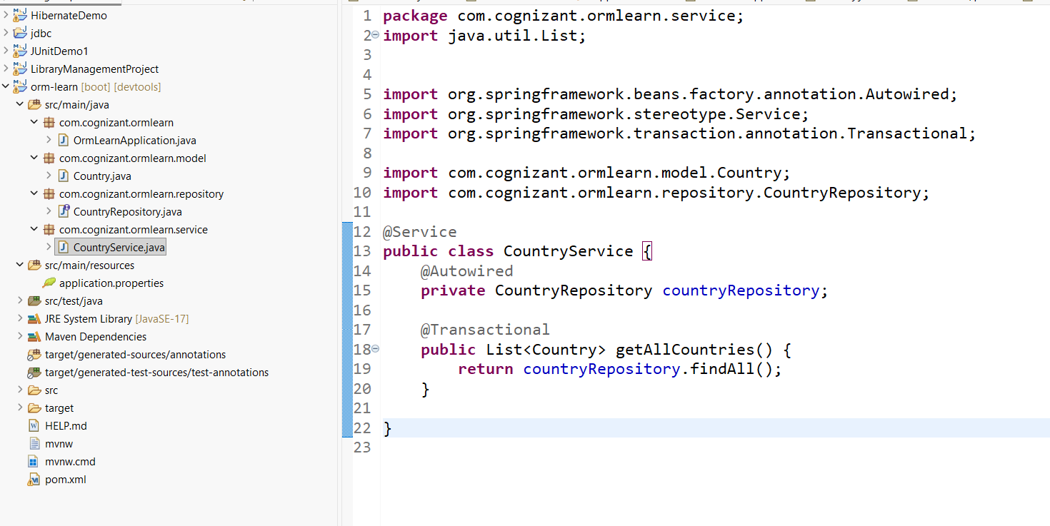
testing
OrmLearnApplication.java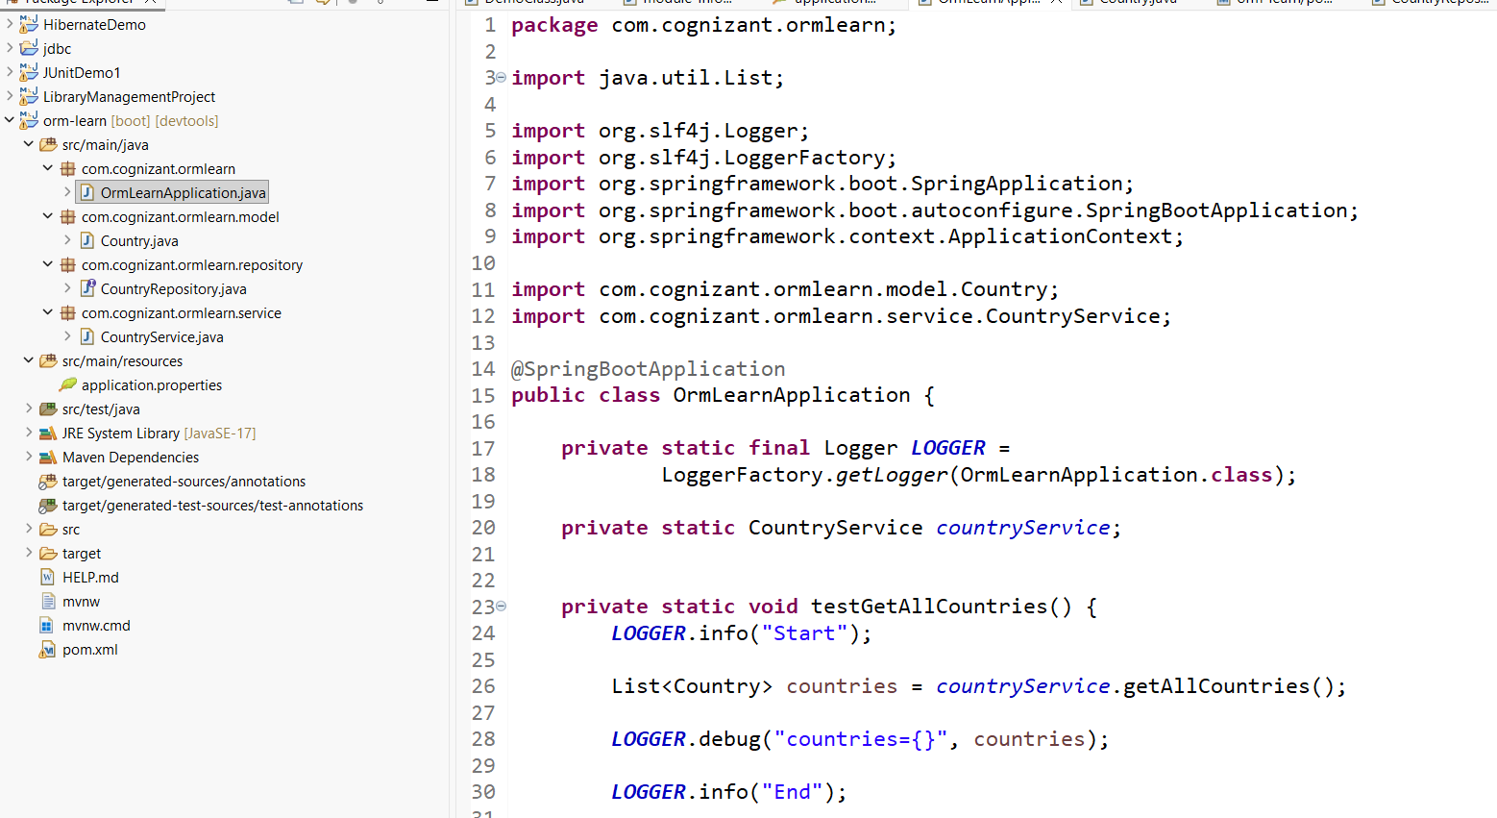
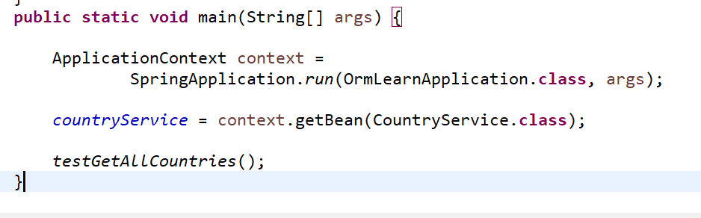
Output:
